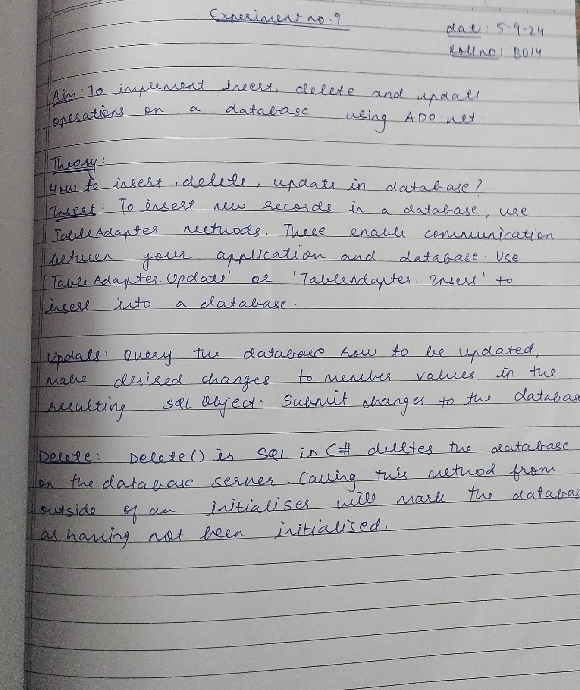

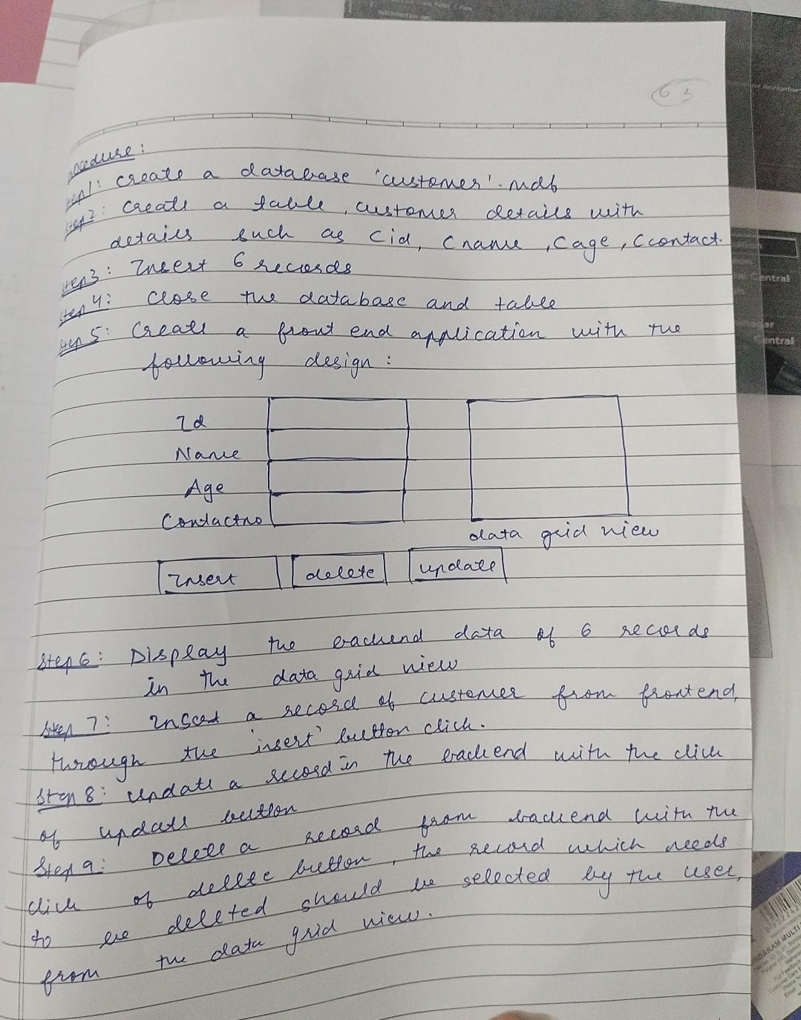

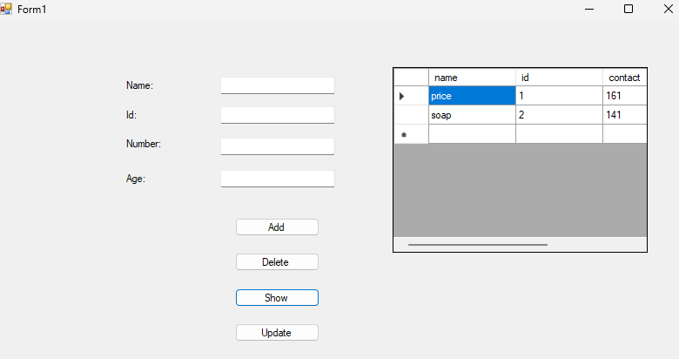

**CODE:**

using System;

using System.Collections.Generic;

using System.ComponentModel;

using System.Data;

using System.Data.SqlClient;

using System.Drawing;

using System.Linq;

using System.Text;

using System.Threading.Tasks;

using System.Windows.Forms;

namespace WindowsFormsApp23

{

public partial class Form1 : Form

{

SqlConnection conn;

public Form1()

{

InitializeComponent();

conn = new SqlConnection(@"Data Source=(LocalDB)\MSSQLLocalDB;AttachDbFilename=C:\Users\SBMPC.Student\source\repos\WindowsFormsApp23\Database1.mdf;Integrated Security=True");

}

private void button1_Click(object sender, EventArgs e)

{

string query = "Insert into [customer_details] (name , id , contact , age) Values(@name , @id , @contact , @age);";

SqlCommand cmd = new SqlCommand(query, conn);

cmd.Parameters.AddWithValue("@name", textBox1.Text);

cmd.Parameters.AddWithValue("@id", textBox2.Text);

cmd.Parameters.AddWithValue("@contact", textBox3.Text);

cmd.Parameters.AddWithValue("@age", textBox4.Text);

conn.Open();

SqlDataAdapter adapter = new SqlDataAdapter(cmd);

DataTable dt = new DataTable();

adapter.Fill(dt);

MessageBox.Show("Saved");

conn.Close();}

private void button2_Click(object sender, EventArgs e)

{ if (dataGridView1.SelectedRows.Count > 0)

{

DataGridViewRow selected = dataGridView1.SelectedRows[0];

string name = selected.Cells[0].Value.ToString(); string query = "Delete from [customer_details] where name = @name ;";

SqlCommand cmd = new SqlCommand(query, conn);

cmd.Parameters.AddWithValue("@name", name);

conn.Open();

SqlDataAdapter adapter = new SqlDataAdapter(cmd);

DataTable dt = new DataTable();

adapter.Fill(dt);

MessageBox.Show("Deleted");

conn.Close();

}

}

private void button3_Click(object sender, EventArgs e)

{

string query = "select * from [customer_details];";

conn.Open();

SqlDataAdapter adapter = new SqlDataAdapter(query,conn);

DataTable dt = new DataTable();

adapter.Fill(dt);

dataGridView1.DataSource= dt;

conn.Close();

}

private void button4_Click_1(object sender, EventArgs e)

{

if (dataGridView1.SelectedRows.Count > 0)

{

DataGridViewRow selected = dataGridView1.SelectedRows[0];

string id = selected.Cells["id"].Value.ToString();

string query = "UPDATE [customer_details] SET name = @name, contact = @contact, age = @age WHERE id = @id;";

SqlCommand cmd = new SqlCommand(query, conn);

cmd.Parameters.AddWithValue("@name", textBox1.Text);

cmd.Parameters.AddWithValue("@contact", textBox3.Text);

cmd.Parameters.AddWithValue("@age", textBox4.Text);

cmd.Parameters.AddWithValue("@id", id);

conn.Open();

cmd.ExecuteNonQuery();

MessageBox.Show("Updated");

string selectQuery = "SELECT * FROM [customer_details];";

SqlDataAdapter adapter = new SqlDataAdapter(selectQuery, conn);

DataTable dt = new DataTable();

adapter.Fill(dt);

dataGridView1.DataSource = dt;

conn.Close();

}

}

}

}